***INSTAGRAME USER ANALYTICS***

SQL TASKS- Firstly- create a database

Create database ig_clone;

Then I enter other query in database which is provided.

A- Marketing Analysis

1 - Loyal user rewards- the marketing team wants to reward the most loyal users,

My task is to identify the five oldest user on Instagram from the provided database.

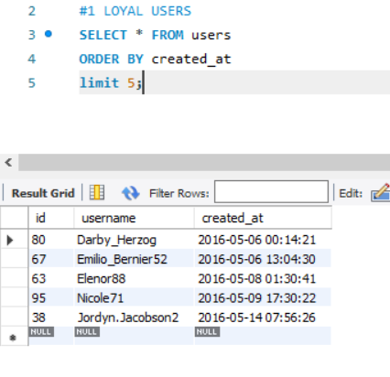

**Conclusion:** These are five oldest Instagram user which we can reward.

2- Inactive user Engagement: The team wants to encourage inactive users to start posting by sending them promotional emails.

My task- Identify users who have never posted a single photo on Instagram.

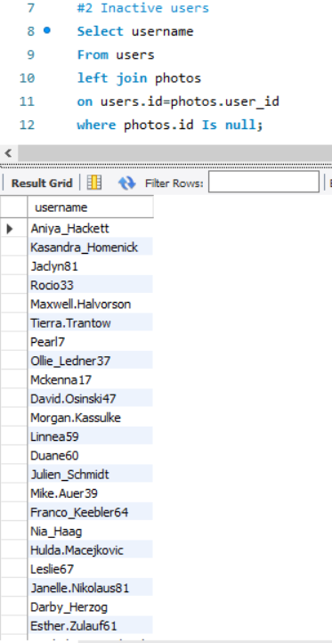

**Conclusion**: Here are these users which are inactive and never posted a single photo on Instagram.

3- Contest Winner Declaration- The team has organized a contest where the user with the most likes on a single photo wins.

My task- Determine the winner of the contest and provide their details to the team.

**Conclusion**: This is the name who gets most like on a single photo.

4- Hashtag Research: A partner brand wants to know the most popular hashtags to use in their posts to reach the most people.

My task- Identify and suggest the top five most commonly used hashtags on the platform.

**Conclusion:** These are the top five hashtags used on the platform.

5- Ad Campaign Launch: The team wants to know the best day of the week to launch ads.

Your Task: Determine the day of the week when most users register on Instagram. Provide insights on when to schedule an ad campaign.

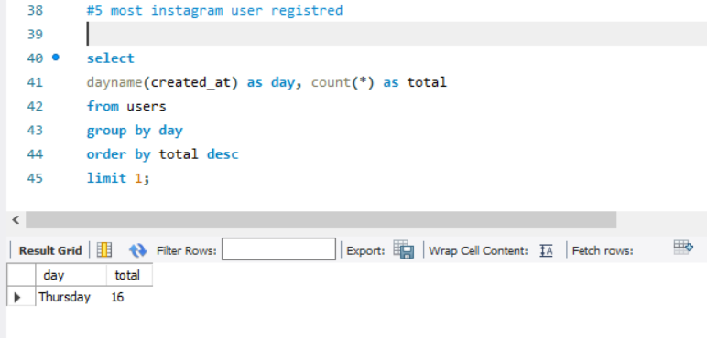

**Conclusion:** The day of the week when most users register on Instagram.

Thursday is the day when schedule an ad campaign.

**B- INVESTOR METRICS:**

1. - User Engagement: Investors want to know if users are still active and posting on Instagram or if they are making fewer posts.

Your Task: Calculate the average number of posts per user on Instagram. Also, provide the total number of photos on Instagram divided by the total number of users.

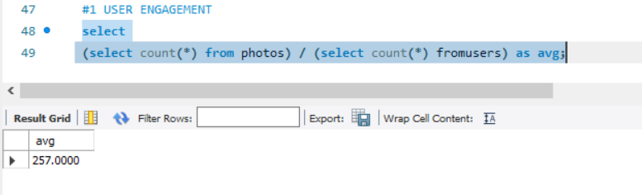

**Conclusion**: 257 Is the average number of posts per user on Instagram.

2 - Bots & Fake Accounts: Investors want to know if the platform is crowded with fake and dummy accounts.

Your Task: Identify users (potential bots) who have liked every single photo on the site, as this is not typically possible for a normal user.

**Conclusion:**

**A) Project Description:** this project aims to extract useful insights from raw data/metadata. Using various database tools, and visualize this to increase the platform efficiency.

**B) Project approach:** this project was executed using SQL. Where I use query to create database from the provided data.

**C) Tech stack used:** the tech stack used included MY SQL Workbench 8.0.32, excellent tool for querying the database , easily accessible and simple.